**Hitachi UX Printer Model 161  
EtherNet/IP Version  
Printer software Version 2.6**

The test results here are using the Hitachi Browser that I wrote. The entire set of read requests can be accomplished in under 7 seconds. The Molex tool is too slow and cumbersome to use for this large an effort.

The source code for the browser has been released as Open Source and is available on GitHub.

<https://github.com/MarvinThompson/HitachiEtherNetIP>

# **Open Cases Previously Submitted to Hitachi**

|  |  |  |  |
| --- | --- | --- | --- |
| **Case** | **Received** | **Closed** | **Subject** |
| 70980 | Tue 3/12/2019 10:26 AM | Fri 4/12/2019 9:51 AM | Calendar Block Shift Code |
| 70999 | Tue 3/12/2019 12:10 PM | Fri 4/12/2019 9:51 AM | Time Count Function |
| 71000 | Tue 3/12/2019 12:11 PM | Fri 4/12/2019 9:51 AM | Counter block |
| 71014 | Tue 3/12/2019 1:53 PM | Fri 4/12/2019 9:51 AM | Calendar Block |
| 71277 | Sun 3/17/2019 12:56 PM | Fri 4/12/2019 9:51 AM | Debugging cijConnect |
| 71389 | Tue 3/19/2019 8:45 AM | Fri 4/12/2019 9:51 AM | IJP Operation Function |
| 71400 | Tue 3/19/2019 10:36 AM | Fri 4/12/2019 9:53 AM | Managing messages saved on the printer |
| 71435 | Tue 3/19/2019 3:21 PM | Fri 4/12/2019 9:51 AM | Print Data Management |
| 71476 | Wed 3/20/2019 10:12 AM | Fri 4/12/2019 9:51 AM | User pattern processing |
| 71488 | Wed 3/20/2019 11:35 AM | Fri 4/12/2019 9:51 AM | Environment Settings |
| 71501 | Wed 3/20/2019 1:31 PM | Fri 4/12/2019 9:51 AM | Unit Information |
| 71535 | Thu 3/21/2019 8:54 AM | Fri 4/12/2019 9:51 AM | Print Format Function |
| 71678 | Mon 3/25/2019 9:38 AM | Fri 4/12/2019 9:51 AM | Add/Delete/Insert columns |
| 71710 | Mon 3/25/2019 1:11 PM | Fri 4/12/2019 9:51 AM | Multi-line setup |
| 72039 | Fri 3/29/2019 12:48 PM |  | Auto Reflection issue |
| 72285 | Wed 4/3/2019 12:35 PM |  | Character Size |

# 0x66 Print data management function

Browser Screen

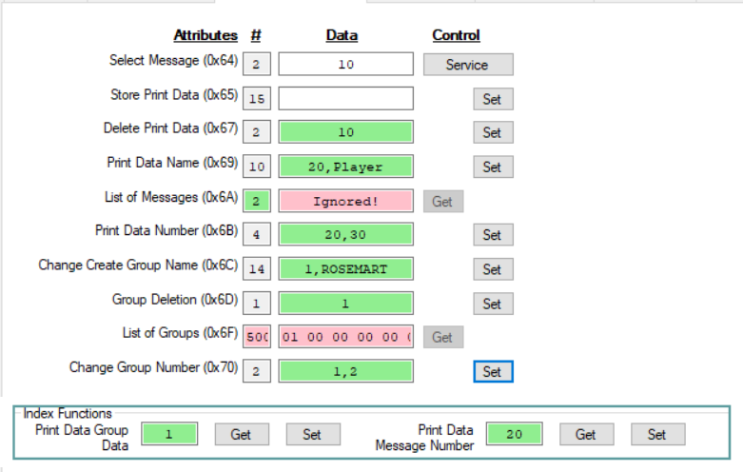

Test Results:

* Select Message (0x64) == Worked. Loaded message 10
* Store Print Data (0x65) == What is type? Could not test
* Delete Print Data (0x67) == Worked. Deleted message 10
* Print Data Name (0x69) == Worked. Changed message name in printer
* List of Messages (0x6A) == Ignored. Causes I/O error.
* Print Data Number (0x6B) == Worked. Changed message number.
* Change Create Group Name (0x6C) == Worked.
* Group Deletion (0x6D) == Worked.
* List of Groups (0x6F) == Worked. See results below.
* Change Group Number (0x70) == Worked.

Traffic during test.

|  |  |  |  |  |  |  |  |  |  |
| --- | --- | --- | --- | --- | --- | --- | --- | --- | --- |
| **Status/Path** | **Access** | **Class** | **Attribute** | **#In** | **Data In** | **Raw In** | **#Out** | **Data Out** | **Raw Out** |
| 32 75 01 6F | Set | IJP_operation | Online_Offline |  |  |  | 1 | On Line | 01 |
| 33 75 01 6F | Get | IJP_operation | Online_Offline | 1 | On Line | 01 |  |  |  |
| 33 7A 01 65 | Get | Index | Automatic_reflection | 1 | 0 | 00 |  |  |  |
| 33 7A 01 64 | Get | Index | Start_Stop_Management_Flag | 1 | 0 | 00 |  |  |  |
| 33 7A 01 6B | Get | Index | Print_Data_Group_Data | 1 | 1 | 01 |  |  |  |
| 33 7A 01 6A | Get | Index | Print_Data_Message_Number | 2 | 1 | 00 01 |  |  |  |
| 33 66 01 6F | Get | Print_data_management | List_of_Groups | 500 | See=> | 01 00 … |  |  |  |
| 34 66 01 64 | Service | Print_data_management | Select_Message |  |  |  | 2 |  | 00 0A |
| 32 66 01 67 | Set | Print_data_management | Delete_Print_Data |  |  |  | 2 | 10 | 00 0A |
| 32 7A 01 6A | Set | Index | Print_Data_Message_Number |  |  |  | 2 | 20 | 00 14 |
| 33 66 01 6F | Get | Print_data_management | List_of_Groups | 500 | See=> | 01 00 … |  |  |  |
| 32 66 01 69 | Set | Print_data_management | Print_Data_Name |  |  |  | 9 | 20,Player | 00 14 50 6C 61 79 65 72 00 |
| 32 66 01 6B | Set | Print_data_management | Print_Data_Number |  |  |  | 4 | 20,30 | 00 14 00 1E |
| 32 66 01 6C | Set | Print_data_management | Change_Create_Group_Name |  |  |  | 10 | 1,ROSEMART | 01 52 4F 53 45 4D 41 52 54 00 |
| 32 66 01 70 | Set | Print_data_management | Change_Group_Number |  |  |  | 2 | 1,2 | 01 02 |
| 33 66 01 6F | Get | Print_data_management | List_of_Groups | 500 | See=> | 01 00 … |  |  |  |

List of Group Names.



# 0x67 Print format function

Browser Screen.

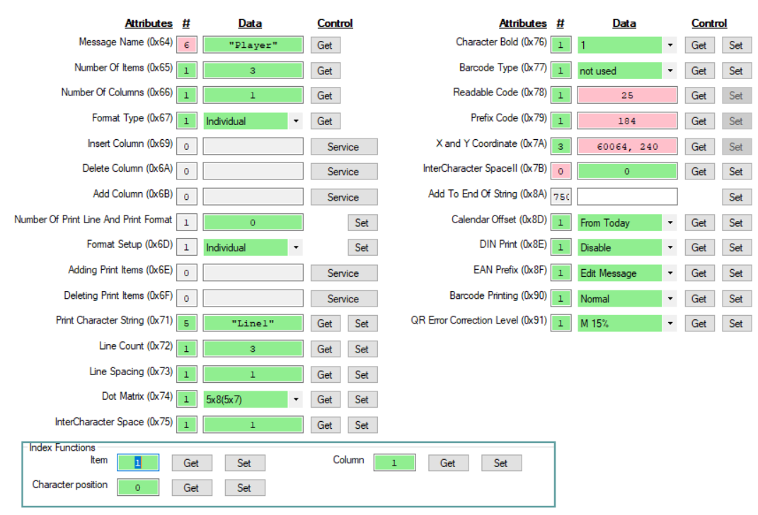

These issues will be sent as a separate request.

Documentation

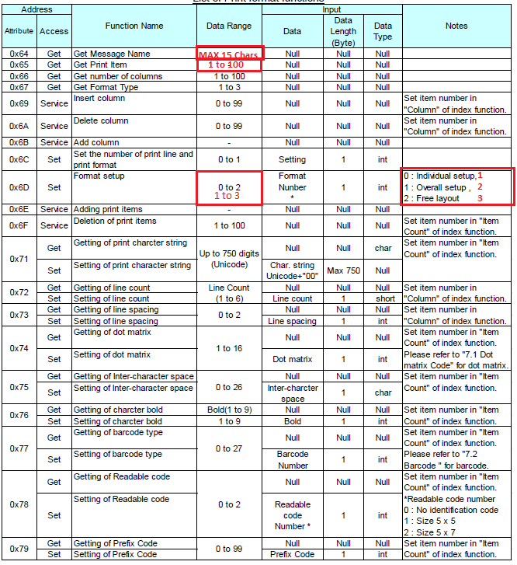

|  |  |  |  |  |  |  |
| --- | --- | --- | --- | --- | --- | --- |
| **Status/Path** | **Access** | **Class** | **Attribute** | **#In** | **Data In** | **Raw In** |
| Print_format | | | | | | |
| 33 67 01 64 | Get | Print_format | Message_Name | 6 | "Player" | 50 6C 61 79 65 72 |
| 33 67 01 65 | Get | Print_format | Number_Of_Items | 1 | 3 | 03 |
| 33 67 01 66 | Get | Print_format | Number_Of_Columns | 1 | 1 | 01 |
| 33 67 01 67 | Get | Print_format | Format_Type | 1 | Individual | 01 |
| 33 67 01 71 | Get | Print_format | Print_Character_String | 5 | "Line1" | 4C 69 6E 65 31 |
| 33 67 01 72 | Get | Print_format | Line_Count | 1 | 3 | 03 |
| 33 67 01 73 | Get | Print_format | Line_Spacing | 1 | 1 | 01 |
| 33 67 01 74 | Get | Print_format | Dot_Matrix | 1 | 5x8(5x7) | 03 |
| 33 67 01 75 | Get | Print_format | InterCharacter_Space | 1 | 1 | 01 |
| 33 67 01 76 | Get | Print_format | Character_Bold | 1 | 1 | 01 |
| 33 67 01 77 | Get | Print_format | Barcode_Type | 1 | not used | 00 |
| 33 67 01 78 | Get | Print_format | Readable_Code | 1 | 25 | 19 |
| 33 67 01 79 | Get | Print_format | Prefix_Code | 1 | 184 | B8 |
| 33 67 01 7A | Get | Print_format | X_and_Y_Coordinate | 3 | 60064, 240 | EA A0 F0 |
| 33 67 01 7B | Get | Print_format | InterCharacter_SpaceII | 0 | 0 |  |
| 33 67 01 8D | Get | Print_format | Calendar_Offset | 1 | From Today | 01 |
| 33 67 01 8E | Get | Print_format | DIN_Print | 1 | Disable | 00 |
| 33 67 01 8F | Get | Print_format | EAN_Prefix | 1 | Edit Message | 00 |
| 33 67 01 90 | Get | Print_format | Barcode_Printing | 1 | Normal | 00 |
| 33 67 01 91 | Get | Print_format | QR_Error_Correction_Level | 1 | M 15% | 00 |

# 0x68 Print specification function

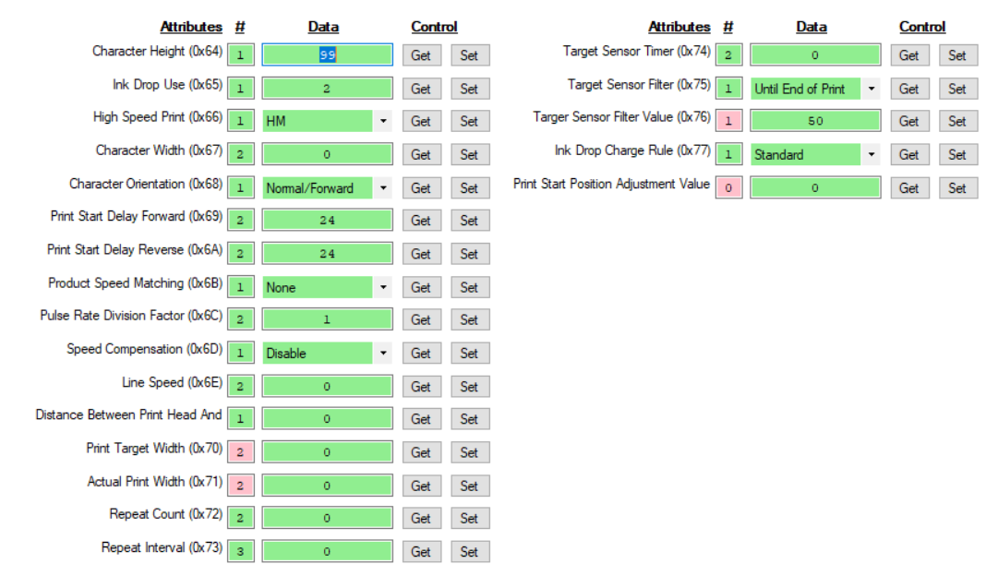

Not possible to test without being able to print. The items in red should be looked at as issues.

|  |  |  |  |  |  |  |
| --- | --- | --- | --- | --- | --- | --- |
| **Status/Path** | **Access** | **Class** | **Attribute** | **#In** | **Data In** | **Raw In** |
| Print_specification | | | | | | |
| 33 68 01 64 | Get | Print_specification | Character_Height | 1 | 99 | 63 |
| 33 68 01 65 | Get | Print_specification | Ink_Drop_Use | 1 | 2 | 02 |
| 33 68 01 66 | Get | Print_specification | High_Speed_Print | 1 | HM | 00 |
| 33 68 01 67 | Get | Print_specification | Character_Width | 2 | 0 | 00 00 |
| 33 68 01 68 | Get | Print_specification | Character_Orientation | 1 | Normal/Forward | 00 |
| 33 68 01 69 | Get | Print_specification | Print_Start_Delay_Forward | 2 | 24 | 00 18 |
| 33 68 01 6A | Get | Print_specification | Print_Start_Delay_Reverse | 2 | 24 | 00 18 |
| 33 68 01 6B | Get | Print_specification | Product_Speed_Matching | 1 | None | 00 |
| 33 68 01 6C | Get | Print_specification | Pulse_Rate_Division_Factor | 2 | 1 | 00 01 |
| 33 68 01 6D | Get | Print_specification | Speed_Compensation | 1 | Disable | 00 |
| 33 68 01 6E | Get | Print_specification | Line_Speed | 2 | 0 | 00 00 |
| 33 68 01 6F | Get | Print_specification | Distance_Between_Print_Head_And_Object | 1 | 0 | 00 |
| 33 68 01 70 | Get | Print_specification | Print_Target_Width | 2 | 0 | 00 00 |
| 33 68 01 71 | Get | Print_specification | Actual_Print_Width | 2 | 0 | 00 00 |
| 33 68 01 72 | Get | Print_specification | Repeat_Count | 2 | 0 | 00 00 |
| 33 68 01 73 | Get | Print_specification | Repeat_Interval | 3 | 0 | 00 00 00 |
| 33 68 01 74 | Get | Print_specification | Target_Sensor_Timer | 2 | 0 | 00 00 |
| 33 68 01 75 | Get | Print_specification | Target_Sensor_Filter | 1 | Until End of Print | 01 |
| 33 68 01 76 | Get | Print_specification | Targer_Sensor_Filter_Value | 1 | 50 | 32 |
| 33 68 01 77 | Get | Print_specification | Ink_Drop_Charge_Rule | 1 | Standard | 00 |
| 33 68 01 78 | Get | Print_specification | Print_Start_Position_Adjustment_Value | 0 | 0 |  |

# 0x69 Calendar function

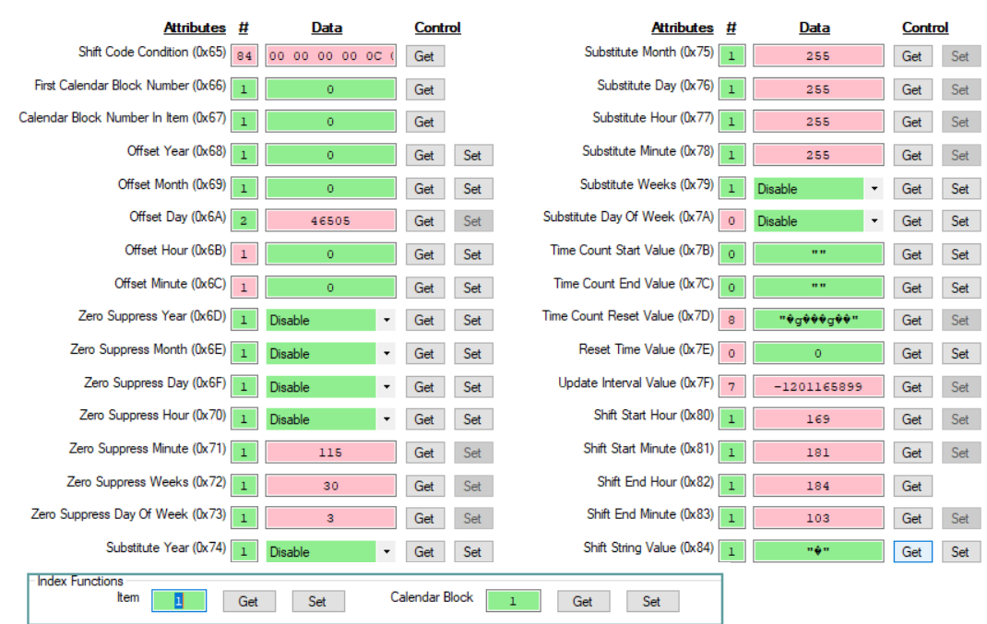

Test results.

* The test results here are long and very complex. It will be addressed as a separate issue.

|  |  |  |  |  |  |  |
| --- | --- | --- | --- | --- | --- | --- |
| **Status/Path** | **Access** | **Class** | **Attribute** | **#In** | **Data In** | **Raw In** |
| Calendar | | | | | | |
| 33 69 01 65 | Get | Calendar | Shift_Code_Condition | 84 | See=> | 00 00 00 00 15 00 00 00 FF FF FF FF 70 77 07 00 |
| 33 69 01 66 | Get | Calendar | First_Calendar_Block_Number | 1 | 0 | 00 |
| 33 69 01 67 | Get | Calendar | Calendar_Block_Number_In_Item | 1 | 0 | 00 |
| 33 69 01 68 | Get | Calendar | Offset_Year | 1 | 0 | 00 |
| 33 69 01 69 | Get | Calendar | Offset_Month | 1 | 0 | 00 |
| 33 69 01 6A | Get | Calendar | Offset_Day | 2 | 46505 | B5 A9 |
| 33 69 01 6B | Get | Calendar | Offset_Hour | 1 | 0 | 00 |
| 33 69 01 6C | Get | Calendar | Offset_Minute | 1 | 0 | 00 |
| 33 69 01 6D | Get | Calendar | Zero_Suppress_Year | 1 | Disable | 00 |
| 33 69 01 6E | Get | Calendar | Zero_Suppress_Month | 1 | Disable | 00 |
| 33 69 01 6F | Get | Calendar | Zero_Suppress_Day | 1 | Disable | 00 |
| 33 69 01 70 | Get | Calendar | Zero_Suppress_Hour | 1 | Disable | 00 |
| 33 69 01 71 | Get | Calendar | Zero_Suppress_Minute | 1 | 115 | 73 |
| 33 69 01 72 | Get | Calendar | Zero_Suppress_Weeks | 1 | 30 | 1E |
| 33 69 01 73 | Get | Calendar | Zero_Suppress_Day_Of_Week | 1 | 3 | 03 |
| 33 69 01 74 | Get | Calendar | Substitute_Year | 1 | Disable | 00 |
| 33 69 01 75 | Get | Calendar | Substitute_Month | 1 | 255 | FF |
| 33 69 01 76 | Get | Calendar | Substitute_Day | 1 | 255 | FF |
| 33 69 01 77 | Get | Calendar | Substitute_Hour | 1 | 255 | FF |
| 33 69 01 78 | Get | Calendar | Substitute_Minute | 1 | 255 | FF |
| 33 69 01 79 | Get | Calendar | Substitute_Weeks | 1 | Disable | 00 |
| 33 69 01 7A | Get | Calendar | Substitute_Day_Of_Week | 0 | Disable |  |
| 33 69 01 7B | Get | Calendar | Time_Count_Start_Value | 0 | "" |  |
| 33 69 01 7C | Get | Calendar | Time_Count_End_Value | 0 | "" |  |
| 33 69 01 7D | Get | Calendar | Time_Count_Reset_Value | 8 | "�g���g��" | BC 67 A9 B5 B8 67 A9 B5 |
| 33 69 01 7E | Get | Calendar | Reset_Time_Value | 0 | 0 |  |
| 33 69 01 7F | Get | Calendar | Update_Interval_Value | 7 | -1201165899 | 67 A9 B5 B8 67 A9 B5 |
| 33 69 01 80 | Get | Calendar | Shift_Start_Hour | 1 | 169 | A9 |
| 33 69 01 81 | Get | Calendar | Shift_Start_Minute | 1 | 181 | B5 |
| 33 69 01 82 | Get | Calendar | Shift_End_Hour | 1 | 184 | B8 |
| 33 69 01 83 | Get | Calendar | Shift_End_Minute | 1 | 103 | 67 |
| 33 69 01 84 | Get | Calendar | Shift_String_Value | 1 | "�" | A9 |

# 0x6B User pattern function

Browser screen

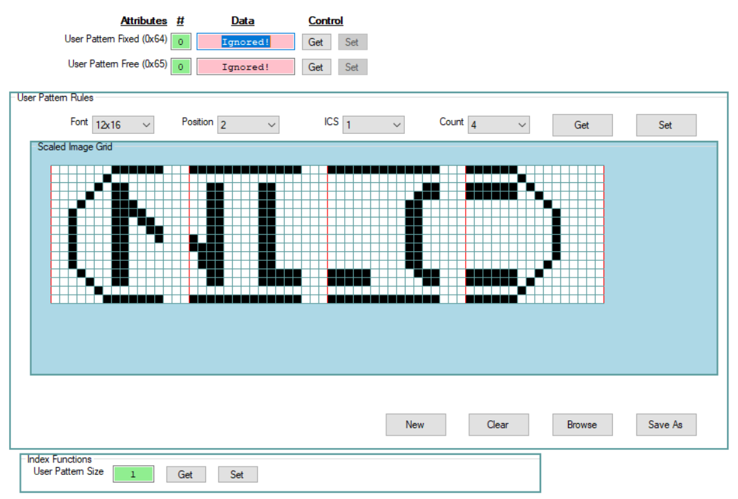

Test results:

* User Pattern Fixed (0x64) Set == Works for 4X5, 5X5, and 5X8(5X7). Fails for the rest ofv the pattern sizes.
* User Pattern Fixed (0x64) Get == Fails for all pattern sizes.
* User Pattern Free (0x65) Get and Set == I did not test.

Documentation:

* The document says “1 to 19” but table only has 15.
* Appears to use column “No.” rather than “Character Size Code”.

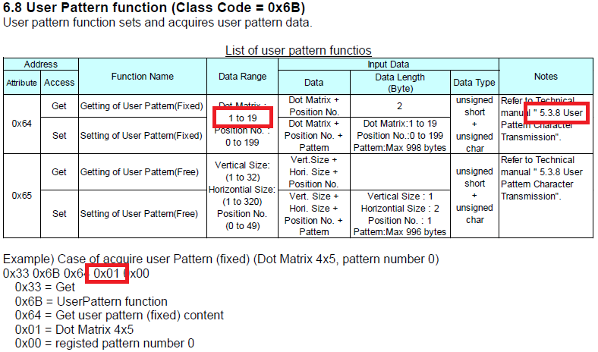

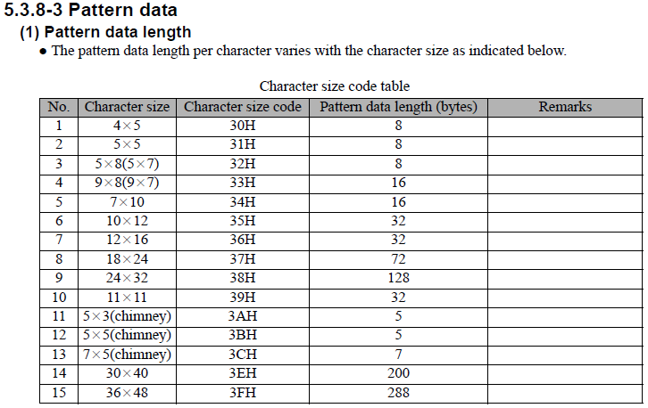

Traffic for 17x16 set of 4 characters. Total of 2 + 32 = 34 bytes sent. Reports successful completion but no user pattern data appears in printer.

|  |  |  |  |  |  |  |
| --- | --- | --- | --- | --- | --- | --- |
| **Status/Path** | **Access** | **Class** | **Attribute** | **#Out** | **Data Out** | **Raw Out** |
| 32 7A 01 6D | Set | Index | User_Pattern_Size | 1 | 12x16 | 07 |
| 32 6B 01 64 | Set | User_pattern | User_Pattern_Fixed | 34 | 7 | 07 02 00 00 00 00 F0 07 08 08 04 10 02 20 01 40 |
| 32 6B 01 64 | Set | User_pattern | User_Pattern_Fixed | 34 | 7 | 07 03 C1 80 71 80 FD BF FD BF 01 80 01 80 01 80 |
| 32 6B 01 64 | Set | User_pattern | User_Pattern_Fixed | 34 | 7 | 07 04 0D 80 0D 80 0D 80 0D 80 0D 80 01 80 01 80 |
| 32 6B 01 64 | Set | User_pattern | User_Pattern_Fixed | 34 | 7 | 07 05 0D B0 0D B0 0D B0 0D B0 0D B0 0D B0 02 40 |

# 0x6C Substitution rules function

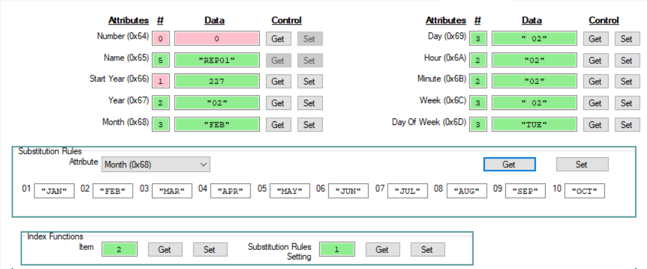

**Implementation Success**

1. Using Index Functions Index and Substitution Rule works priperly.
2. Setting and retrieving the substitution rule settings works properly
3. Getting the name works (did not work in 2.03). Have not tried to set a different name.

**Implementation Issues**

1. Attempts to get the rule number returns either 0 bytes or 3 bytes (01 E3 07). The 3 byte results look like.
   1. 01 == could be the rule number
   2. E3 07 == is 2019 when interpreted as Little Endian
2. Attempts to get the start year returns 1 byte (E3). Could be the leading byte of 2019.
3. Attempts to change the start year to 2018 does not change the start year in the printer.
4. Set Auto Reflection to 1, set the values, and set Auto Reflection to 0 clears all the substitutions for all attributes (month, dat, …).

**Documentation Issues**

1. 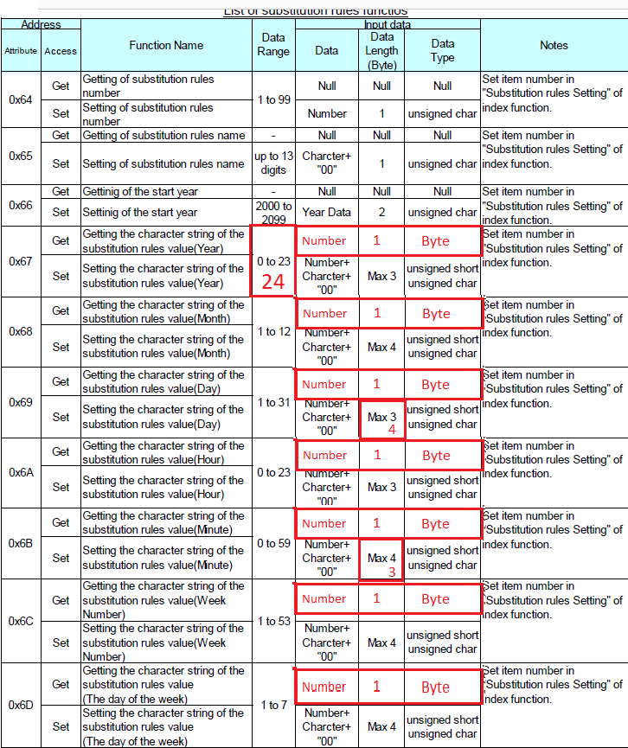

**XML for setting Substitution values**

<Label ClockSystem="24-Hour" Registration="101" GroupNumber="00" GroupName=""

Name="EthernetIP" BeRestrictive="False" UseHalfSpace="False" Format="Individual" Version="3">

<Printer Model="UX" Make="Hitachi">

<Substitution Rule="01" StartYear="2019" Delimeter="/">

<Year Base="00">00/01/02/03/04/05/06/07/08/09</Year>

<Year Base="10">10/11/12/13/14/15/16/17/18/19</Year>

<Year Base="20">20/21/22/23</Year>

<Month Base="1">JAN/FEB/MAR/APR/MAY/JUN/JUL/AUG/SEP/OCT/NOV/DEC</Month>

<Day Base="01">01/02/03/04/05/06/07/08/09/10</Day>

<Day Base="11">11/02/13/14/15/16/17/18/19/20</Day>

<Day Base="21">21/22/23/24/25/26/27/28/29/30/31</Day>

<Hour Base="00">00/01/02/03/04/05/06/07/08/09</Hour>

<Hour Base="10">10/11/12/13/14/15/16/17/18/19</Hour>

<Hour Base="20">20/21/22/23</Hour>

<Minute Base="00">00/01/02/03/04/05/06/07/08/09</Minute>

<Minute Base="10">10/11/12/13/14/15/16/17/18/19</Minute>

<Minute Base="20">20/21/22/23/24/25/26/27/28/29</Minute>

<Minute Base="30">30/31/32/33/34/35/36/37/38/39</Minute>

<Minute Base="40">40/41/42/43/44/45/46/47/48/49</Minute>

<Minute Base="50">50/51/52/53/54/55/56/57/58/59</Minute>

<Week Base="01">01/02/03/04/05/06/07/08/09/10</Week>

<Week Base="11">11/12/13/14/15/16/17/18/19/20</Week>

<Week Base="21">21/22/23/24/25/26/27/28/29/30</Week>

<Week Base="31">31/32/33/34/35/36/37/38/39/40</Week>

<Week Base="41">41/42/43/44/45/46/47/48/49/50/51/52/53</Week>

<DayOfWeek Base="1">MON/TUE/WED/THU/FRI/SAT/SUN</DayOfWeek>

</Substitution>

</Printer>

</Label>

Traffic for loading page

|  |  |  |  |  |  |  |  |  |  |
| --- | --- | --- | --- | --- | --- | --- | --- | --- | --- |
| **Status/Path** | **Access** | **Class** | **Attribute** | **#In** | **Data In** | **Raw In** | **#Out** | **Data Out** | **Raw Out** |
| Substitution_rules | | | | | | | | | |
| 33 6C 01 64 | Get | Substitution_rules | Number | 0 | 0 |  |  |  |  |
| 33 6C 01 65 | Get | Substitution_rules | Name | 5 | "REP01" | 52 45 50 30 31 | 1 | 1 | 01 |
| 33 6C 01 66 | Get | Substitution_rules | Start_Year | 1 | 227 | E3 |  |  |  |
| 33 6C 01 67 | Get | Substitution_rules | Year | 2 | "01" | 30 31 | 1 | 1 | 01 |
| 33 6C 01 68 | Get | Substitution_rules | Month | 3 | "JAN" | 4A 41 4E | 1 | 1 | 01 |
| 33 6C 01 69 | Get | Substitution_rules | Day | 3 | " 01" | 20 30 31 | 1 | 1 | 01 |
| 33 6C 01 6A | Get | Substitution_rules | Hour | 2 | "01" | 30 31 | 1 | 1 | 01 |
| 33 6C 01 6B | Get | Substitution_rules | Minute | 2 | "01" | 30 31 | 1 | 1 | 01 |
| 33 6C 01 6C | Get | Substitution_rules | Week | 3 | " 01" | 20 30 31 | 1 | 1 | 01 |
| 33 6C 01 6D | Get | Substitution_rules | Day_Of_Week | 3 | "MON" | 4D 4F 4E | 1 | 1 | 01 |

Traffic for set.

|  |  |  |  |  |  |  |
| --- | --- | --- | --- | --- | --- | --- |
| **Status/Path** | **Access** | **Class** | **Attribute** | **#Out** | **Data Out** | **Raw Out** |
| 32 6C 01 6D | Set | Substitution_rules | Day_Of_Week | 5 | 1,"MON" | 01 4D 4F 4E 00 |
| 32 6C 01 6D | Set | Substitution_rules | Day_Of_Week | 5 | 2,"TUE" | 02 54 55 45 00 |
| 32 6C 01 6D | Set | Substitution_rules | Day_Of_Week | 5 | 3,"WED" | 03 57 45 44 00 |
| 32 6C 01 6D | Set | Substitution_rules | Day_Of_Week | 5 | 4,"THU" | 04 54 48 55 00 |
| 32 6C 01 6D | Set | Substitution_rules | Day_Of_Week | 5 | 5,"FRI" | 05 46 52 49 00 |
| 32 6C 01 6D | Set | Substitution_rules | Day_Of_Week | 5 | 6,"SAT" | 06 53 41 54 00 |
| 32 6C 01 6D | Set | Substitution_rules | Day_Of_Week | 5 | 7,"SUN" | 07 53 55 4E 00 |

Traffic for Get.

|  |  |  |  |  |  |  |  |  |  |
| --- | --- | --- | --- | --- | --- | --- | --- | --- | --- |
| **Status/Path** | **Access** | **Class** | **Attribute** | **#In** | **Data In** | **Raw In** | **#Out** | **Data Out** | **Raw Out** |
| **Traffic to retrieve substitution data** | | | | | | | | | |
| 00 -- O.K. -- 33 6C 01 6D | Get | Substitution_rules | Day_Of_Week | 3 | "MON" | 4D 4F 4E | 1 | 1 | 01 |
| 00 -- O.K. -- 33 6C 01 6D | Get | Substitution_rules | Day_Of_Week | 3 | "TUE" | 54 55 45 | 1 | 2 | 02 |
| 00 -- O.K. -- 33 6C 01 6D | Get | Substitution_rules | Day_Of_Week | 3 | "WED" | 57 45 44 | 1 | 3 | 03 |
| 00 -- O.K. -- 33 6C 01 6D | Get | Substitution_rules | Day_Of_Week | 3 | "THU" | 54 48 55 | 1 | 4 | 04 |
| 00 -- O.K. -- 33 6C 01 6D | Get | Substitution_rules | Day_Of_Week | 3 | "FRI" | 46 52 49 | 1 | 5 | 05 |
| 00 -- O.K. -- 33 6C 01 6D | Get | Substitution_rules | Day_Of_Week | 3 | "SAT" | 53 41 54 | 1 | 6 | 06 |
| 00 -- O.K. -- 33 6C 01 6D | Get | Substitution_rules | Day_Of_Week | 3 | "SUN" | 53 55 4E | 1 | 7 | 07 |

|  |  |  |  |  |  |  |  |  |  |
| --- | --- | --- | --- | --- | --- | --- | --- | --- | --- |
| **Status/Path** | **Access** | **Class** | **Attribute** | **#In** | **Data In** | **Raw In** | **#Out** | **Data Out** | **Raw Out** |
| **Set Item and substitution rule** | | | | | | | | | |
| 00 -- O.K. -- 33 7A 01 66 | Get | Index | Item | 2 | 1 | 00 01 |  |  |  |
| 00 -- O.K. -- 33 7A 01 6C | Get | Index | Substitution_Rules_Setting | 1 | 1 | 01 |  |  |  |
| **Read one instance of each attribute** | | | | | | | | | |
| 00 -- O.K. -- 33 6C 01 64 | Get | Substitution_rules | Number | 3 | 123655 | 01 E3 07 |  |  |  |
| 00 -- O.K. -- 33 6C 01 65 | Get | Substitution_rules | Name | 5 | "REP01" | 52 45 50 30 31 | 1 | 1 | 01 |
| 00 -- O.K. -- 33 6C 01 66 | Get | Substitution_rules | Start_Year | 1 | 226 | E2 |  |  |  |
| 00 -- O.K. -- 33 6C 01 67 | Get | Substitution_rules | Year | 2 | "01" | 30 31 | 1 | 1 | 01 |
| 00 -- O.K. -- 33 6C 01 68 | Get | Substitution_rules | Month | 3 | "JAN" | 4A 41 4E | 1 | 1 | 01 |
| 00 -- O.K. -- 33 6C 01 69 | Get | Substitution_rules | Day | 3 | " 01" | 20 30 31 | 1 | 1 | 01 |
| 00 -- O.K. -- 33 6C 01 6A | Get | Substitution_rules | Hour | 2 | "01" | 30 31 | 1 | 1 | 01 |
| 00 -- O.K. -- 33 6C 01 6B | Get | Substitution_rules | Minute | 2 | "01" | 30 31 | 1 | 1 | 01 |
| 00 -- O.K. -- 33 6C 01 6C | Get | Substitution_rules | Week | 3 | " 01" | 20 30 31 | 1 | 1 | 01 |
| 00 -- O.K. -- 33 6C 01 6D | Get | Substitution_rules | Day_Of_Week | 3 | "MON" | 4D 4F 4E | 1 | 1 | 01 |

|  |  |  |  |  |  |  |  |  |  |
| --- | --- | --- | --- | --- | --- | --- | --- | --- | --- |
| **Write the Month Substitutions** | | | | | | | | | |
| 00 -- O.K. -- 32 6C 01 68 | Set | Substitution_rules | Month |  |  |  | 5 | JAN | 01 4A 41 4E 00 |
| 00 -- O.K. -- 32 6C 01 68 | Set | Substitution_rules | Month |  |  |  | 5 | FEB | 02 46 45 42 00 |
| 00 -- O.K. -- 32 6C 01 68 | Set | Substitution_rules | Month |  |  |  | 5 | MAR | 03 4D 41 52 00 |
| 00 -- O.K. -- 32 6C 01 68 | Set | Substitution_rules | Month |  |  |  | 5 | APR | 04 41 50 52 00 |
| 00 -- O.K. -- 32 6C 01 68 | Set | Substitution_rules | Month |  |  |  | 5 | MAY | 05 4D 41 59 00 |
| 00 -- O.K. -- 32 6C 01 68 | Set | Substitution_rules | Month |  |  |  | 5 | JUN | 06 4A 55 4E 00 |
| 00 -- O.K. -- 32 6C 01 68 | Set | Substitution_rules | Month |  |  |  | 5 | JUL | 07 4A 55 4C 00 |
| 00 -- O.K. -- 32 6C 01 68 | Set | Substitution_rules | Month |  |  |  | 5 | AUG | 08 41 55 47 00 |
| 00 -- O.K. -- 32 6C 01 68 | Set | Substitution_rules | Month |  |  |  | 5 | SEP | 09 53 45 50 00 |
| 00 -- O.K. -- 32 6C 01 68 | Set | Substitution_rules | Month |  |  |  | 5 | OCT | 0A 4F 43 54 00 |
| 00 -- O.K. -- 32 6C 01 68 | Set | Substitution_rules | Month |  |  |  | 5 | NOV | 0B 4E 4F 56 00 |
| 00 -- O.K. -- 32 6C 01 68 | Set | Substitution_rules | Month |  |  |  | 5 | DEC | 0C 44 45 43 00 |
| **Read the month Substitutions** | | | | | | | | | |
| 00 -- O.K. -- 33 6C 01 68 | Get | Substitution_rules | Month | 3 | "JAN" | 4A 41 4E | 1 | 1 | 01 |
| 00 -- O.K. -- 33 6C 01 68 | Get | Substitution_rules | Month | 3 | "FEB" | 46 45 42 | 1 | 2 | 02 |
| 00 -- O.K. -- 33 6C 01 68 | Get | Substitution_rules | Month | 3 | "MAR" | 4D 41 52 | 1 | 3 | 03 |
| 00 -- O.K. -- 33 6C 01 68 | Get | Substitution_rules | Month | 3 | "APR" | 41 50 52 | 1 | 4 | 04 |
| 00 -- O.K. -- 33 6C 01 68 | Get | Substitution_rules | Month | 3 | "MAY" | 4D 41 59 | 1 | 5 | 05 |
| 00 -- O.K. -- 33 6C 01 68 | Get | Substitution_rules | Month | 3 | "JUN" | 4A 55 4E | 1 | 6 | 06 |
| 00 -- O.K. -- 33 6C 01 68 | Get | Substitution_rules | Month | 3 | "JUL" | 4A 55 4C | 1 | 7 | 07 |
| 00 -- O.K. -- 33 6C 01 68 | Get | Substitution_rules | Month | 3 | "AUG" | 41 55 47 | 1 | 8 | 08 |
| 00 -- O.K. -- 33 6C 01 68 | Get | Substitution_rules | Month | 3 | "SEP" | 53 45 50 | 1 | 9 | 09 |
| 00 -- O.K. -- 33 6C 01 68 | Get | Substitution_rules | Month | 3 | "OCT" | 4F 43 54 | 1 | 10 | 0A |
| 00 -- O.K. -- 33 6C 01 68 | Get | Substitution_rules | Month | 3 | "NOV" | 4E 4F 56 | 1 | 11 | 0B |
| 00 -- O.K. -- 33 6C 01 68 | Get | Substitution_rules | Month | 3 | "DEC" | 44 45 43 | 1 | 12 | 0C |
| **Set auto reflection** | | | | | | | | | |
| 00 -- O.K. -- 32 7A 01 65 | Set | Index | Automatic_reflection |  |  |  | 1 | 1 | 01 |
| 00 -- O.K. -- 33 7A 01 65 | Get | Index | Automatic_reflection | 1 | 1 | 01 |  |  |  |

|  |  |  |  |  |  |  |  |  |  |
| --- | --- | --- | --- | --- | --- | --- | --- | --- | --- |
| **Write the Month Substitutions** | | | | | | | | | |
| 00 -- O.K. -- 32 6C 01 68 | Set | Substitution_rules | Month |  |  |  | 5 | JAN | 01 4A 41 4E 00 |
| 00 -- O.K. -- 32 6C 01 68 | Set | Substitution_rules | Month |  |  |  | 5 | FEB | 02 46 45 42 00 |
| 00 -- O.K. -- 32 6C 01 68 | Set | Substitution_rules | Month |  |  |  | 5 | MAR | 03 4D 41 52 00 |
| 00 -- O.K. -- 32 6C 01 68 | Set | Substitution_rules | Month |  |  |  | 5 | APR | 04 41 50 52 00 |
| 00 -- O.K. -- 32 6C 01 68 | Set | Substitution_rules | Month |  |  |  | 5 | MAY | 05 4D 41 59 00 |
| 00 -- O.K. -- 32 6C 01 68 | Set | Substitution_rules | Month |  |  |  | 5 | JUN | 06 4A 55 4E 00 |
| 00 -- O.K. -- 32 6C 01 68 | Set | Substitution_rules | Month |  |  |  | 5 | JUL | 07 4A 55 4C 00 |
| 00 -- O.K. -- 32 6C 01 68 | Set | Substitution_rules | Month |  |  |  | 5 | AUG | 08 41 55 47 00 |
| 00 -- O.K. -- 32 6C 01 68 | Set | Substitution_rules | Month |  |  |  | 5 | SEP | 09 53 45 50 00 |
| 00 -- O.K. -- 32 6C 01 68 | Set | Substitution_rules | Month |  |  |  | 5 | OCT | 0A 4F 43 54 00 |
| 00 -- O.K. -- 32 6C 01 68 | Set | Substitution_rules | Month |  |  |  | 5 | NOV | 0B 4E 4F 56 00 |
| 00 -- O.K. -- 32 6C 01 68 | Set | Substitution_rules | Month |  |  |  | 5 | DEC | 0C 44 45 43 00 |
| **Clear Auto Reflection** | | | | | | | | | |
| 00 -- O.K. -- 32 7A 01 65 | Set | Index | Automatic_reflection |  |  |  | 1 | 0 | 00 |
| 00 -- O.K. -- 33 7A 01 65 | Get | Index | Automatic_reflection | 1 | 0 | 00 |  |  |  |
| **Read the month Substitutions** | | | | | | | | | |
| 00 -- O.K. -- 33 6C 01 68 | Get | Substitution_rules | Month |  |  |  | 1 | 1 | 01 |
| 00 -- O.K. -- 33 6C 01 68 | Get | Substitution_rules | Month |  |  |  | 1 | 2 | 02 |
| 00 -- O.K. -- 33 6C 01 68 | Get | Substitution_rules | Month |  |  |  | 1 | 3 | 03 |
| 00 -- O.K. -- 33 6C 01 68 | Get | Substitution_rules | Month |  |  |  | 1 | 4 | 04 |
| 00 -- O.K. -- 33 6C 01 68 | Get | Substitution_rules | Month |  |  |  | 1 | 5 | 05 |
| 00 -- O.K. -- 33 6C 01 68 | Get | Substitution_rules | Month |  |  |  | 1 | 6 | 06 |
| 00 -- O.K. -- 33 6C 01 68 | Get | Substitution_rules | Month |  |  |  | 1 | 7 | 07 |
| 00 -- O.K. -- 33 6C 01 68 | Get | Substitution_rules | Month |  |  |  | 1 | 8 | 08 |
| 00 -- O.K. -- 33 6C 01 68 | Get | Substitution_rules | Month |  |  |  | 1 | 9 | 09 |
| 00 -- O.K. -- 33 6C 01 68 | Get | Substitution_rules | Month |  |  |  | 1 | 10 | 0A |
| 00 -- O.K. -- 33 6C 01 68 | Get | Substitution_rules | Month |  |  |  | 1 | 11 | 0B |
| 00 -- O.K. -- 33 6C 01 68 | Get | Substitution_rules | Month |  |  |  | 1 | 12 | 0C |

# 0x71 Enviroment setting function

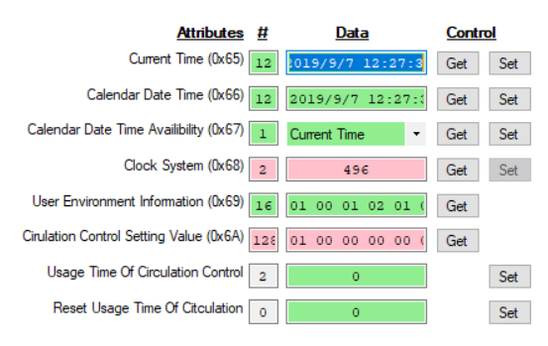

Attributes and comments

* 0x65 & 0x66 == Get
  + Command = 33 71 01 65
  + Response = E3 07 03 00 14 00 0B 00 10 00 31 00  
            YYYYY MMMMM DDDDD hhhhh mmmmm sssss
  + Two bytes each in Little Endian format
* 0x65 == Set (attempt to change month )
  + Command = 32 71 01 65
  + Data = E3 07 04 00 14 00 0B 00 10 00 31 00  
         YYYYY MMMMM DDDDD hhhhh mmmmm sssss
  + Response = Success The time was not changed in the printer
* 0x67 == Worked
* 0x68 == has an issue
  + Get == 33 71 01 68
  + Response = 01 F0 (an extra byte is returned.  The first byte is correct)
  + Set = 32 71 01 68
  + Data = 02
  + Response = Success (the clock system was changed)
* 0x69 & 0x6A == Need documentation
* 0x6B & 0x6C == Do not know how to test or when I would use them.

|  |  |  |  |  |  |  |
| --- | --- | --- | --- | --- | --- | --- |
| **Status/Path** | **Access** | **Class** | **Attribute** | **#In** | **Data In** | **Raw In** |
| Enviroment_setting | | | | | | |
| 33 71 01 65 | Get | Enviroment_setting | Current_Time | 12 | 2019/9/7 13:6:22 | E3 07 09 00 07 00 0D 00 06 00 16 00 |
| 33 71 01 66 | Get | Enviroment_setting | Calendar_Date_Time | 12 | 2019/9/7 13:6:22 | E3 07 09 00 07 00 0D 00 06 00 16 00 |
| 33 71 01 67 | Get | Enviroment_setting | Calendar_Date_Time_Availibility | 1 | Current Time | 01 |
| 33 71 01 68 | Get | Enviroment_setting | Clock_System | 2 | 496 | 01 F0 |
| 33 71 01 69 | Get | Enviroment_setting | User_Environment_Information | 16 | See=> | 01 00 01 02 01 02 02 01 00 01 00 00 01 00 01 00 |
| 33 71 01 6A | Get | Enviroment_setting | Cirulation_Control_Setting_Value | 128 | See=> | 01 00 00 00 00 00 00 00 00 00 00 00 00 00 00 00 |

# 0x73 Unit Information function

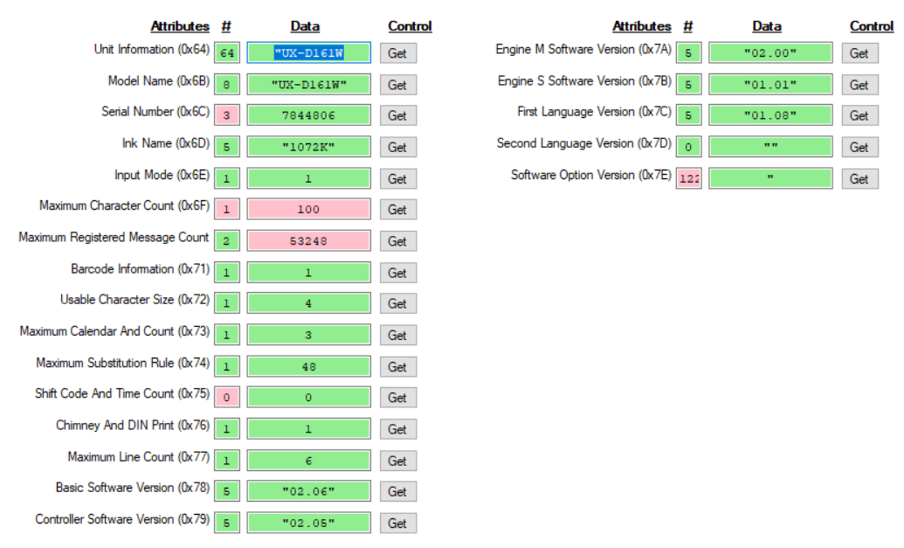

Attribute and comments

* 0x64 == Returns 64 bytes
  + Get = 33 73 01 64
  + Response = 55 58 2D 44 31 36 31 57 00 00 00 00 C6 B3 77 00 31 30 37 32 4B 2B DD BE 69 B2 0D 2C 53 31 30 31 38 2B DD BE 69 B2 0D 00 00 00 00 00 02 00 E8 03 D0 07 01 00 04 00 08 00 63 00 01 00 01 00 06 00
    - 55 58 2D 44 31 36 31 57 ("UX-D161W")
    - 00 00 00 00 C6 B3 77 00 == 0x6D Response( 7844806 machine serial number in some unknown format)
    - 31 30 37 32 4B = 0x6D Response (“1072K”)
    - 2C 53 31 30 31 38 00 00 00 00 00 00 00 00 00 00 00 00 00 00 00 00 00 == Just hanging here.  Do not know where it goes.  Might be part of the ink type (“,S1018”)
    - 02 00 == 0x6E Response (This is what is actually in the machine but 0x6E reports “01”)
    - E8 03 == 0x6F Response (This is 1000 and should be the response for 0x6F.  But 0x6f reports a “64”)
    - D0 07 == 0x70 Response (This is 2000 and should be the response for 0x70.  But 0x70 reports “D0 00”)
    - 01 00 == 0x71 Response valid
    - 04 00 == 0x72 Response valid
    - 08 00 == 0x73 Response valid
    - 63 00 == 0x74 Response valid
    - 01 00 == 0x75 Response valid
    - 01 00 == 0x76 Response valid
    - 06 00 == 0x77 Response valid
* 0x6B thru 0x77 are described above
* 0x78 thru 0x7d == Work fine
* 0x7E == Causes a printer hang.  {“Unable to read data from the transport connection: A connection attempt failed because the connected party did not properly respond after a period of time, or established connection failed because connected host has failed to respond.")

|  |  |  |  |  |  |  |
| --- | --- | --- | --- | --- | --- | --- |
| **Status/Path** | **Access** | **Class** | **Attribute** | **#In** | **Data In** | **Raw In** |
| Unit_Information | | | | | | |
| 33 73 01 64 | Get | Unit_Information | Unit_Information | 64 | "UX-D161W | 55 58 2D 44 31 36 31 57 00 00 00 00 C6 B3 77 00 |
| 33 73 01 6B | Get | Unit_Information | Model_Name | 8 | "UX-D161W" | 55 58 2D 44 31 36 31 57 |
| 33 73 01 6C | Get | Unit_Information | Serial_Number | 3 | 7844806 | C6 B3 77 |
| 33 73 01 6D | Get | Unit_Information | Ink_Name | 5 | "1072K" | 31 30 37 32 4B |
| 33 73 01 6E | Get | Unit_Information | Input_Mode | 1 | 1 | 01 |
| 33 73 01 6F | Get | Unit_Information | Maximum_Character_Count | 1 | 100 | 64 |
| 33 73 01 70 | Get | Unit_Information | Maximum_Registered_Message_Count | 2 | 53296 | D0 30 |
| 33 73 01 71 | Get | Unit_Information | Barcode_Information | 1 | 1 | 01 |
| 33 73 01 72 | Get | Unit_Information | Usable_Character_Size | 1 | 4 | 04 |
| 33 73 01 73 | Get | Unit_Information | Maximum_Calendar_And_Count | 1 | 3 | 03 |
| 33 73 01 74 | Get | Unit_Information | Maximum_Substitution_Rule | 1 | 48 | 30 |
| 33 73 01 75 | Get | Unit_Information | Shift_Code_And_Time_Count | 0 | 0 |  |
| 33 73 01 76 | Get | Unit_Information | Chimney_And_DIN_Print | 1 | 1 | 01 |
| 33 73 01 77 | Get | Unit_Information | Maximum_Line_Count | 1 | 6 | 06 |
| 33 73 01 78 | Get | Unit_Information | Basic_Software_Version | 5 | "02.06" | 30 32 2E 30 36 |
| 33 73 01 79 | Get | Unit_Information | Controller_Software_Version | 5 | "02.05" | 30 32 2E 30 35 |
| 33 73 01 7A | Get | Unit_Information | Engine_M_Software_Version | 5 | "02.00" | 30 32 2E 30 30 |
| 33 73 01 7B | Get | Unit_Information | Engine_S_Software_Version | 5 | "01.01" | 30 31 2E 30 31 |
| 33 73 01 7C | Get | Unit_Information | First_Language_Version | 5 | "01.08" | 30 31 2E 30 38 |
| 33 73 01 7D | Get | Unit_Information | Second_Language_Version | 0 | "" |  |
| 33 73 01 7E | Get | Unit_Information | Software_Option_Version | 122 | " | 00 00 2E 00 00 00 00 00 00 00 00 00 00 00 00 00 |

# 0x74 Operation management function

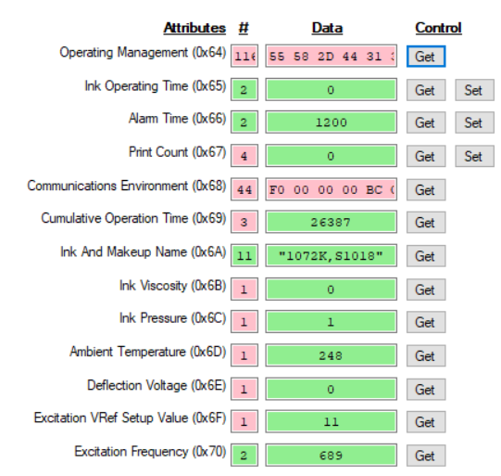

Test results:

* These may have issues since my printer does not have ink.
* All items in red do not match the documentation in terms of amount of data sent.

|  |  |  |  |  |  |  |
| --- | --- | --- | --- | --- | --- | --- |
| **Status/Path** | **Access** | **Class** | **Attribute** | **#In** | **Data In** | **Raw In** |
| Operation_management | | | | | | |
| 33 74 01 64 | Get | Operation_management | Operating_Management | 116 | See=> | 55 58 2D 44 31 36 31 57 00 00 00 00 C6 B3 77 00 |
| 33 74 01 65 | Get | Operation_management | Ink_Operating_Time | 2 | 0 | 00 00 |
| 33 74 01 66 | Get | Operation_management | Alarm_Time | 2 | 1200 | 04 B0 |
| 33 74 01 67 | Get | Operation_management | Print_Count | 4 | 0 | 00 00 00 00 |
| 33 74 01 68 | Get | Operation_management | Communications_Environment | 44 | See=> | F0 00 00 00 BC CF F0 B6 80 79 07 00 01 00 00 00 |
| 33 74 01 69 | Get | Operation_management | Cumulative_Operation_Time | 3 | 26368 | 00 67 00 |
| 33 74 01 6A | Get | Operation_management | Ink_And_Makeup_Name | 11 | "1072K,S1018" | 31 30 37 32 4B 2C 53 31 30 31 38 |
| 33 74 01 6B | Get | Operation_management | Ink_Viscosity | 1 | 0 | 00 |
| 33 74 01 6C | Get | Operation_management | Ink_Pressure | 0 | 0 |  |
| 33 74 01 6D | Get | Operation_management | Ambient_Temperature | 1 | 248 | F8 |
| 33 74 01 6E | Get | Operation_management | Deflection_Voltage | 1 | 0 | 00 |
| 33 74 01 6F | Get | Operation_management | Excitation_VRef_Setup_Value | 1 | 11 | 0B |
| 33 74 01 70 | Get | Operation_management | Excitation_Frequency | 2 | 689 | 02 B1 |

# 0x75 IJP operation function

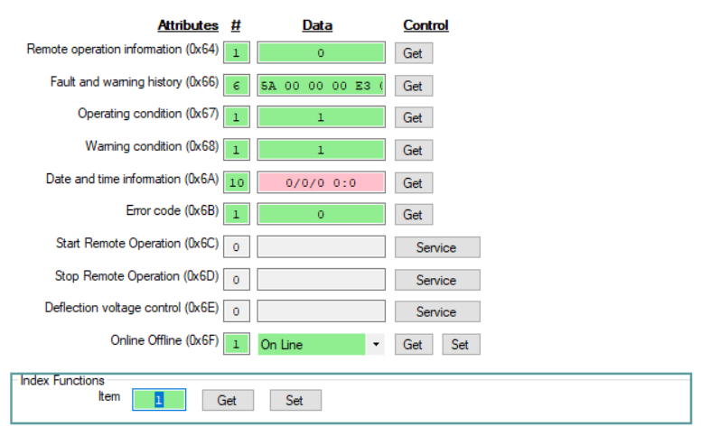

Here are the Attribute codes and retrieved values

* 0x64 / 00 == Do not know what it means.  Reception not possible?
* 0x66 /  0E 00 00 00 E3 07 == Do not know what it means
  + 0E == 14 which is the number of Com errors currently in my printer
  + 00 00 00 == Do not know what they mean
  + E3 07 == 2019 in Little End format
* 0x67 / 01 == In standby?
* 0x68 / 01 == Ink Low warning? (I have no ink in my printer)
* 0x6A / 00 00 00 00 00 00 00 00 00 00 == Sometimes it shows a data and time
* 0x6B == Always shows 00.
* 0x6C & 0x6D == I understand
* 0x6E == What does this do?
* 0x6F == Works fine

Changing the Item Number in the Index Function seems to change some values but have not figured a pattern.

Would like to see a service call to clear all entries from the Alarm History.

|  |  |  |  |  |  |  |  |  |  |
| --- | --- | --- | --- | --- | --- | --- | --- | --- | --- |
| **Status/Path** | **Access** | **Class** | **Attribute** | **#In** | **Data In** | **Raw In** | **#Out** | **Data Out** | **Raw Out** |
| IJP_operation | | | | | | | | | |
| 33 75 01 64 | Get | IJP_operation | Remote_operation_information | 1 | 0 | 00 |  |  |  |
| 33 75 01 66 | Get | IJP_operation | Fault_and_warning_history | 6 | See=> | 5A 00 00 00 E3 07 |  |  |  |
| 33 75 01 67 | Get | IJP_operation | Operating_condition | 1 | 1 | 01 |  |  |  |
| 33 75 01 68 | Get | IJP_operation | Warning_condition | 1 | 1 | 01 |  |  |  |
| 33 75 01 6A | Get | IJP_operation | Date_and_time_information | 10 | 2019/9/6 13:42 | E3 07 09 00 06 00 0D 00 2A 00 |  |  |  |
| 33 75 01 6B | Get | IJP_operation | Error_code | 1 | 0 | 00 |  |  |  |
| 33 75 01 6F | Get | IJP_operation | Online_Offline | 1 | On Line | 01 |  |  |  |

# 0x79 Count function

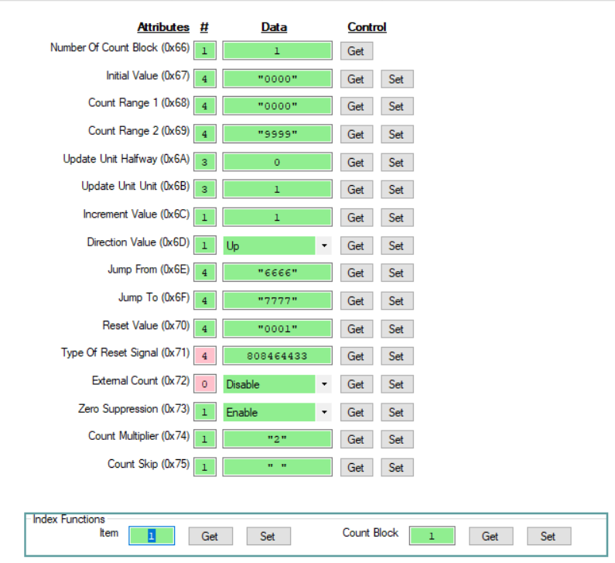

Test Results:

* Almost everything worked.
* Differences indicated in yellow below.

|  |  |  |  |  |  |  |  |  |  |
| --- | --- | --- | --- | --- | --- | --- | --- | --- | --- |
| **Status/Path** | **Access** | **Class** | **Attribute** | **#In** | **Data In** | **Raw In** | **#Out** | **Data Out** | **Raw Out** |
| **Setup the Counter** | | | | | | | | | |
| 00 -- O.K. -- 32 7A 01 66 | Set | Index | Item |  |  |  | 2 | 1 | 00 01 |
| 00 -- O.K. -- 32 7A 01 6E | Set | Index | Count_Block |  |  |  | 1 | 1 | 01 |
| 00 -- O.K. -- 32 67 01 74 | Set | Print_format | Dot_Matrix |  |  |  | 1 | 5x8(5x7) | 03 |
| 00 -- O.K. -- 32 67 01 75 | Set | Print_format | InterCharacter_Space |  |  |  | 1 | 1 | 01 |
| 00 -- O.K. -- 32 67 01 71 | Set | Print_format | Print_Character_String |  |  |  | 9 | "{{CCCC}}" | 7B 7B 43 43 43 43 7D 7D 00 |
| 00 -- O.K. -- 32 79 01 67 | Set | Count | Initial_Value |  |  |  | 5 | "0001" | 30 30 30 31 00 |
| 00 -- O.K. -- 32 79 01 68 | Set | Count | Count_Range_1 |  |  |  | 5 | "0000" | 30 30 30 30 00 |
| 00 -- O.K. -- 32 79 01 69 | Set | Count | Count_Range_2 |  |  |  | 5 | "9999" | 39 39 39 39 00 |
| 00 -- O.K. -- 32 79 01 6E | Set | Count | Jump_From |  |  |  | 5 | "6666" | 36 36 36 36 00 |
| 00 -- O.K. -- 32 79 01 6F | Set | Count | Jump_To |  |  |  | 5 | "7777" | 37 37 37 37 00 |
| 00 -- O.K. -- 32 79 01 6C | Set | Count | Increment_Value |  |  |  | 1 | 1 | 01 |
| 00 -- O.K. -- 32 79 01 6D | Set | Count | Direction_Value |  |  |  | 1 | Up | 01 |
| 00 -- O.K. -- 32 79 01 73 | Set | Count | Zero_Suppression |  |  |  | 1 | Enable | 01 |
| 00 -- O.K. -- 32 79 01 74 | Set | Count | Count_Multiplier |  |  |  | 2 | "2" | 32 00 |
| 00 -- O.K. -- 32 79 01 70 | Set | Count | Reset_Value |  |  |  | 5 | "0001" | 30 30 30 31 00 |
| 00 -- O.K. -- 32 79 01 75 | Set | Count | Count_Skip |  |  |  | 2 | "0" | 30 00 |
| **Read Back the Counter** | | | | | | | | | |
| 00 -- O.K. -- 33 79 01 66 | Get | Count | Number_Of_Count_Block | 1 | 1 | 01 |  |  |  |
| 00 -- O.K. -- 33 79 01 67 | Get | Count | Initial_Value | 4 | "0000" | 30 30 30 30 |  |  |  |
| 00 -- O.K. -- 33 79 01 68 | Get | Count | Count_Range_1 | 4 | "0000" | 30 30 30 30 |  |  |  |
| 00 -- O.K. -- 33 79 01 69 | Get | Count | Count_Range_2 | 4 | "9999" | 39 39 39 39 |  |  |  |
| 00 -- O.K. -- 33 79 01 6A | Get | Count | Update_Unit_Halfway | 3 | 0 | 00 00 00 |  |  |  |
| 00 -- O.K. -- 33 79 01 6B | Get | Count | Update_Unit_Unit | 3 | 1 | 00 00 01 |  |  |  |
| 00 -- O.K. -- 33 79 01 6C | Get | Count | Increment_Value | 1 | 1 | 01 |  |  |  |
| 00 -- O.K. -- 33 79 01 6D | Get | Count | Direction_Value | 1 | Up | 01 |  |  |  |
| 00 -- O.K. -- 33 79 01 6E | Get | Count | Jump_From | 4 | "6666" | 36 36 36 36 |  |  |  |
| 00 -- O.K. -- 33 79 01 6F | Get | Count | Jump_To | 4 | "7777" | 37 37 37 37 |  |  |  |
| 00 -- O.K. -- 33 79 01 70 | Get | Count | Reset_Value | 4 | "0001" | 30 30 30 31 |  |  |  |
| 00 -- O.K. -- 33 79 01 71 | Get | Count | Type_Of_Reset_Signal | 4 | 808464433 | 30 30 30 31 |  |  |  |
| 00 -- O.K. -- 33 79 01 72 | Get | Count | External_Count | 0 | Disable |  |  |  |  |
| 00 -- O.K. -- 33 79 01 73 | Get | Count | Zero_Suppression | 1 | Enable | 01 |  |  |  |
| 00 -- O.K. -- 33 79 01 74 | Get | Count | Count_Multiplier | 1 | "2" | 32 |  |  |  |
| 00 -- O.K. -- 33 79 01 75 | Get | Count | Count_Skip | 1 | " " | 20 |  |  |  |

# 0x7A Index function

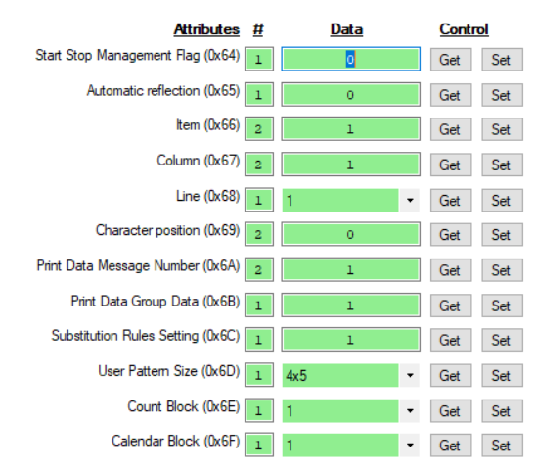

Test results:

* All functions seem to operate properly.

|  |  |  |  |  |  |  |  |  |  |
| --- | --- | --- | --- | --- | --- | --- | --- | --- | --- |
| **Status/Path** | **Access** | **Class** | **Attribute** | **#In** | **Data In** | **Raw In** | **#Out** | **Data Out** | **Raw Out** |
| Index | | | | | | | | | |
| 33 7A 01 64 | Get | Index | Start_Stop_Management_Flag | 1 | 0 | 00 |  |  |  |
| 33 7A 01 65 | Get | Index | Automatic_reflection | 1 | 0 | 00 |  |  |  |
| 33 7A 01 66 | Get | Index | Item | 2 | 1 | 00 01 |  |  |  |
| 33 7A 01 67 | Get | Index | Column | 2 | 1 | 00 01 |  |  |  |
| 33 7A 01 68 | Get | Index | Line | 1 | 1 | 01 |  |  |  |
| 33 7A 01 69 | Get | Index | Character_position | 2 | 0 | 00 00 |  |  |  |
| 33 7A 01 6A | Get | Index | Print_Data_Message_Number | 2 | 1 | 00 01 |  |  |  |
| 33 7A 01 6B | Get | Index | Print_Data_Group_Data | 1 | 1 | 01 |  |  |  |
| 33 7A 01 6C | Get | Index | Substitution_Rules_Setting | 1 | 1 | 01 |  |  |  |
| 33 7A 01 6D | Get | Index | User_Pattern_Size | 1 | 4x5 | 01 |  |  |  |
| 33 7A 01 6E | Get | Index | Count_Block | 1 | 1 | 01 |  |  |  |
| 33 7A 01 6F | Get | Index | Calendar_Block | 1 | 1 | 01 |  |  |  |

# **Character Size**

There are two different mappings for character size:

User Pattern Function (0x6B) Attributes 0x64 and 0x65 refer to Table 5.3.8-3 of the UX Technical Spec

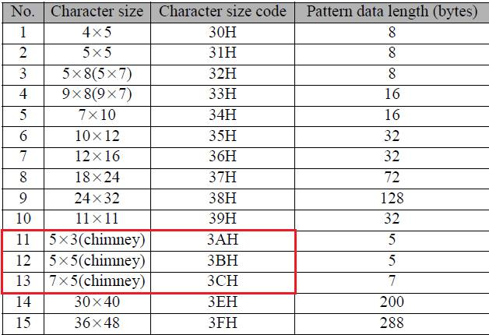

Print Format Function (0x67) Attribute 0x74 refers to table 7.4 of the EtherNet/IP document

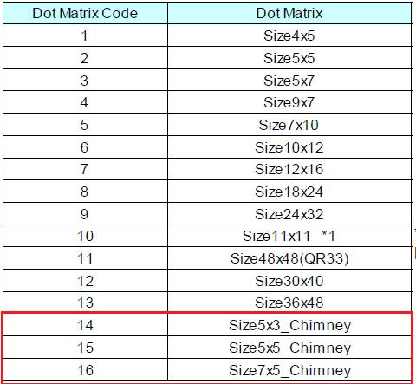

Issues with implementation:

* The UX Spec is 0-Origin == 0 thru 15 (missing 13 (3DH))
* The EIP Spec is 1-origin == 1 thru 16
* The location of the chimney fonts differs.

This causes issues with the implementation.  It would be nice for both tables to use the EIP Mapping.